**Experiment No. 05**

**Aim: To understand and implement exception handling**

**Code and Output:**

**Value Error**

List = [1,2,3,4,5]

a,b,c = List

print(a)

print(b)

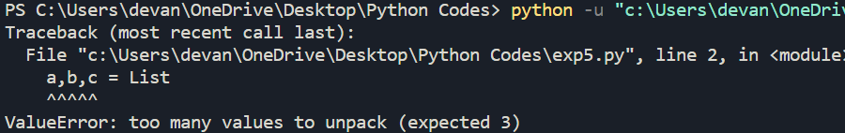print(c)

**ZeroDivision Error**

n = 9

m = 0

print(n/m)

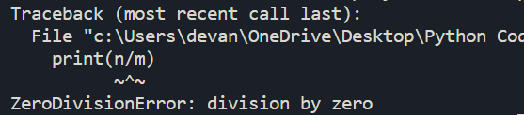

**Import Error**

Import xyz

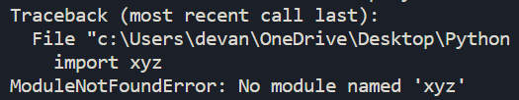

**Key Error**

dict_data={'2' : 'two', '4' : 'four', '6' : 'six'}

dict_data['5']

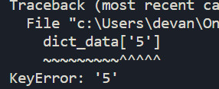**Index Error**

list_data = [1, 2, 3, 4, 5]

x = list_data[6]

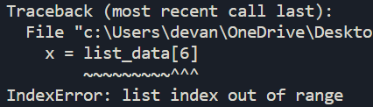**User Defined Exception**

class BaseError(Exception):pass

class HighValueError(Exception):pass

class LowValueError(Exception):pass

value = 29

while(1):

try:

n=int(input("Enter number:"))

if n > value:

raise HighValueError

elif n < value:

raise LowValueError

except LowValueError:

print("Very Low Value, Give input again")

print()

except HighValueError:

print("Very High value , give input again")

print()

else:

print("Nice!Correct answer")

break

